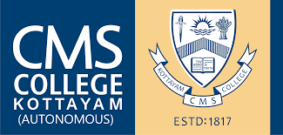 | CMS COLLEGE KOTTAYAM  (AUTONOMOUS)  (Affiliated to Mahatma Gandhi University, Accredited by NAAC at ‘A+’ Grade)  Kottayam – 686 001, Kerala, India, Tel: 0481-2566002  www.cmscollege.ac.in

No: CMS/CE/0785/2026 27.05.2026
Notification- Revaluation Results

The revaluation result of the following examinations are published:
- VI Semester CBCS UG (Regular–2023 Admissions/ Supplementary –
2021 Admissions / Mercy chance- 2019 Admissions ) Degree Examinations – March 2026
- V Semester CBCS UG and B.Voc. (Special Supplementary –2023 Admissions) Degree Examinations – February 2026
- IV Semester CSS PG (Regular –2024 Admissions/ Supplementary–2023 Admissions) Degree Examinations – March 2026
- III Semester CSS PG (Special Supplementary–2024 Admissions) Degree Examinations – February 2026

Results can be viewed through the following link:
https://services.cmscollege.ac.in/SemesterResult/SemesterResult/Result_Homes

Dr. NISHA P ARAVIND
Controller of Examinations

